HEMA Training Simulator

*Authors:* Eric Reesor | 100970401

Conlan LaFreniere | 100971291

*Supervisor:* Dr. Samuel Ajila

Abstract

This project is for an Historical European Martial Arts, or HEMA, training simulator application. The major components of this application are a wand-style input device to track the user’s hand position, a 3d rendering tool for visualizing opponents and to track simulated collisions, and a library of stances and motions against which the user’s inputs can be graded. All these components working in tandem will allow the user to train themselves in HEMA protocols. It will be designed and implemented by Eric Reesor and Conlan LaFreniere, under the supervision of Professor Samuel Ajila. This project is to be worked on for 8 months from September 2017 through April 11th, 2018.

Objective

The objective of this project is to design and develop a reliable and accurate HEMA training simulator, which will allow the user to learn and practice the set of stances and actions which make up the art of the German longsword. More specifically, to teach and reinforce instinctual reactions one will require to spar and fight safely. This will be done though sequential drills and reaction based training, according with HEMA traditions. Our goal is to have a working prototype that will allow the user to walk through different training exercises, following along with a motion control input device that will allow the program to correct user errors, as a teacher would.

Background

HEMA, or Historical European Martial Arts, is not a specific discipline despite what its name implies. HEMA actually refers more broadly to the masses of specialized disciplines developed in Europe over the late Middle Ages and Renaissance. It encompasses everything from hand-to-hand combat, to fencing and long-swordsmanship. An often neglected section of European history, the study of HEMA often leads down the roads of archeology, society, art, and most importantly literature. Many modern HEMA collectives are not descended from the practitioners of yore, but instead formed by avid scholars who study the writings of the old European masters.

This project will focus mainly on the Liechtenauer style of fencing, using the Federschwert. This was a style of swordplay originally taught by the Holy Roman Empire, and has since informed the German school of fencing, and which uses a federschwert (feather sword) as the main weapon. The core of the Liechtenauer system is to constantly provide an immediate threat to the opponent while simultaneously defending yourself. This is done through managing one’s distance and timing of actions while being keenly aware of what the opponent is doing. These actions are exact in regards to the shape and structure of the movements made

Technical Overview

This project, due to its scope, can be decomposed into three core functionalities: handling user input/output, rendering the simulator, and recognizing proper HEMA form. These functionalities correspond to the three major tasks involved in this project: designing a wand-style motion controller interface, developing a 3d engine for rendering the simulation, and developing a pattern recognition system that will handle parsing inputs from the wireless input device.

Eric, as a Computer Systems Engineering student will be largely responsible for the hardware components of this system, be it designing a new input device or interfacing existing hardware. Conlan, as a Software Engineering student will largely be responsible for the software components, such as the 3d renderer or the HEMA recognition software. Academically, this will serve to strengthen our understanding of hardware/software interactions and computer system design. The design and implementation of the user control system will reinforce the concepts learned in our real-time systems course as well as the computer system design project. The design of the simulation environment, which includes the AI system, will teach us new technologies and give us an opportunity to apply the concepts from our software development courses

As discussedabove, this project can be decomposed into three core functionalities: handling user input/output, rendering the simulator, and recognizing proper HEMA form. To this end, a Model View Controller architecture would best serve us. This also separates our main concerns of handling player inputs (View), rendering the simulator (Model), and simulating proper HEMA form (Controller). We are planning to use a handheld sensor that can relay positional information in real-time will be required, such as a Wii remote. This sensor will then need to be connected to our 3d engine. The Unity Game Engine will be used for the model, to allow us access to their built in 3d rendering software, collision detection, and cross platform capabilities. The HEMA training simulation will be implemented as a library of recognized gestures and would be capable of evaluating the user’s performance based on logical rules defined by the Liechtenauer system.

Timetable

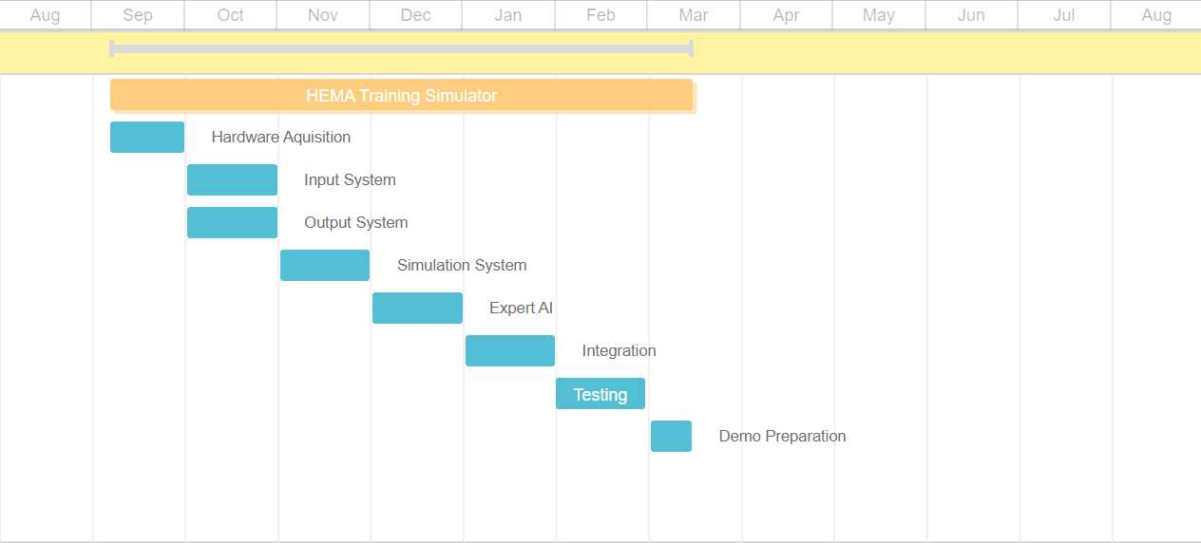

Equipment/Software – *Subject to Change*

Unity Game Engine – Free License

Fabricated Federschwert style Wii remote holder

Wii Remote Motion Plus through Open Source Wii-to-Unity API

Display Options

* Cellphone as VR headset
* Oculus/Vive Headset
* TV/Computer Monitor

References

ARMA. (n.d.). A Short Introduction to the Martial Arts of Renaissance Europe. Retrieved September 16, 2017, from http://www.thearma.org/HEMA.htm

Boorman, D. (2017, August 31). What is a Part of Historical European Martial Arts (HEMA)?. Retrieved September 17, 2017, from https://www.academieduello.com/news-blog/part-historical-european-martial-arts-hema/

Taylor, K. (2005, January). Kronos:. Retrieved September 17, 2017, from http://www.ejmas.com/kronos/NewHist1350-1699.htm

Johannes Liechtenauer. (2017, August 22). Retrieved September 18, 2017, from http://wiktenauer.com/wiki/Johannes_Liechtenauer